

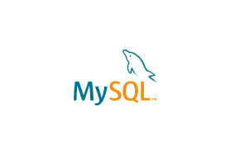

Explore

Certainly! [In a nutshell, **MySQL** is an **open-source relational database management system** that stores data in tables and allows users to define, manipulate, control, and query data using **Structured Query Language (SQL)**](https://www.digitalocean.com/community/tutorials/what-is-mysql) [1](https://www.digitalocean.com/community/tutorials/what-is-mysql)[2](https://bing.com/search?q=mysql+database+definition)[3](https://www.oracle.com/mysql/what-is-mysql/)[4](https://techterms.com/definition/mysql).

Here are **five free reference links** where you can learn more about MySQL:

1. [**DigitalOcean’s MySQL Tutorial**](https://www.digitalocean.com/community/tutorials/what-is-mysql): A comprehensive guide covering MySQL basics and advanced topics.
2. [**GeeksforGeeks - What is MySQL?**](https://www.geeksforgeeks.org/what-is-mysql/): Detailed explanations, examples, and practical insights into MySQL.
3. [**MySQL Official Documentation**](https://dev.mysql.com/doc/refman/8.0/en/what-is-mysql.html): The official MySQL documentation provides in-depth information on various aspects of MySQL.
4. [**Built In - What Is MySQL?**](https://builtin.com/data-science/mysql): Learn how MySQL works and its role in managing data for large websites.
5. [**Oracle’s MySQL Overview**](https://www.oracle.com/mysql/what-is-mysql/): Oracle’s official page with an overview of MySQL and its significance.

Happy learning! 🌟📚